Chapter 18, Solution 29.

(a) f(t) = F ⁻¹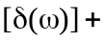 F ⁻¹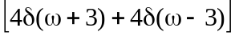
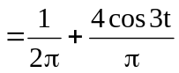 = 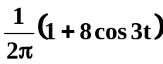

- If 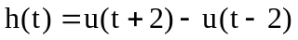

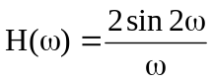
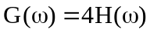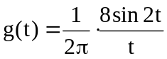
g(t) = 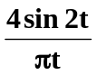

- Since the Fouier transform of cos(at) is = 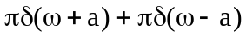

Using the reversal property,

or F ⁻¹